蔡汉霖 HANLIN CAI 832002117 20122161 **（I am the only one member in my group）**

**Lab2 : The CMOS Inverter**

**Object:**

The purpose of this experiment is to construct a logical inverter composed of PMOS and NMOS. In this experiment, the characteristics and non-ideality of the inverter will be studied.

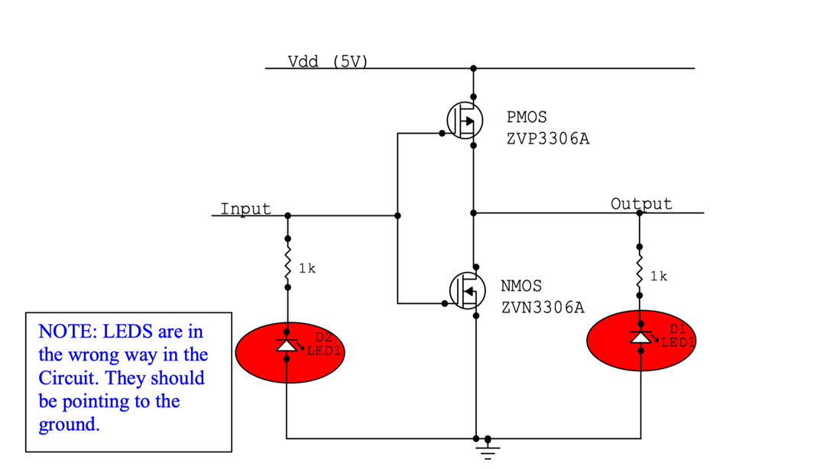

**Task.1**

**Fig1:**

The circuit wiring diagram is as follows:

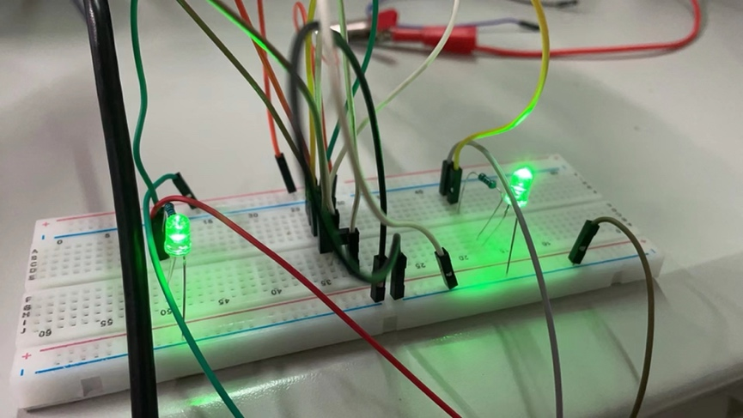

**Fig2:**

I use the function generator, set the amplitude to 3VPP and the signal frequency to 1kHZ, and then connect the oscilloscope to observe the correct square wave as shown in the figure below.

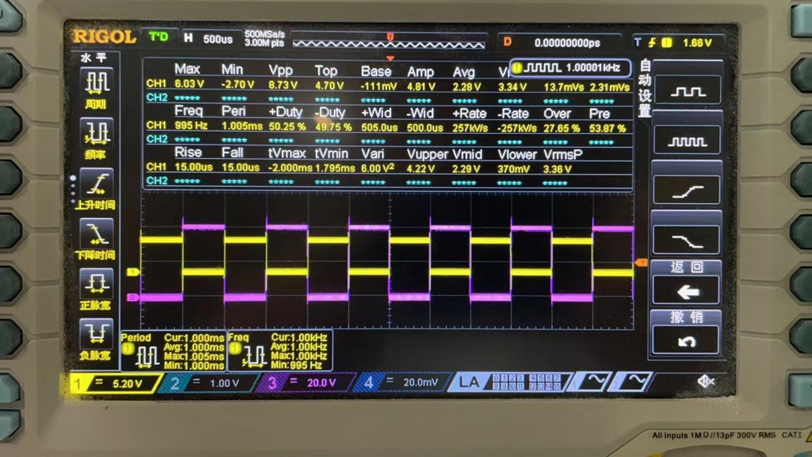

**Fig3:**

Then I set the amplitude to 4VPP and the signal frequency to 10HZ.

I can see that two LED lights flash alternately,

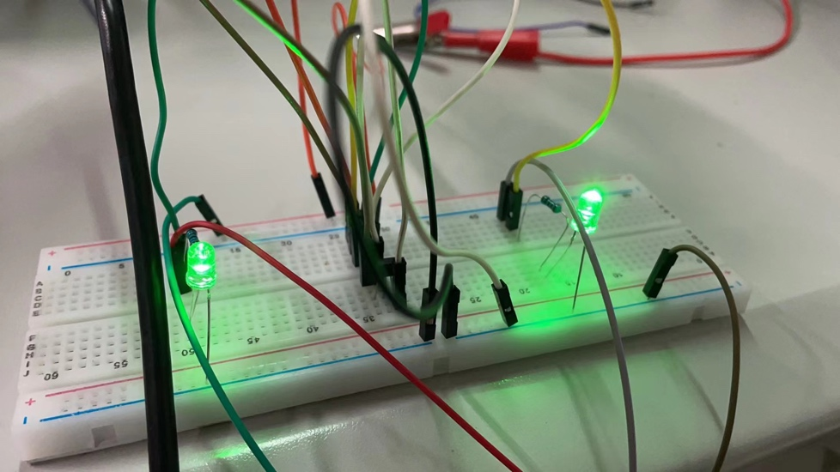

And oscilloscope waveform display is as follows:

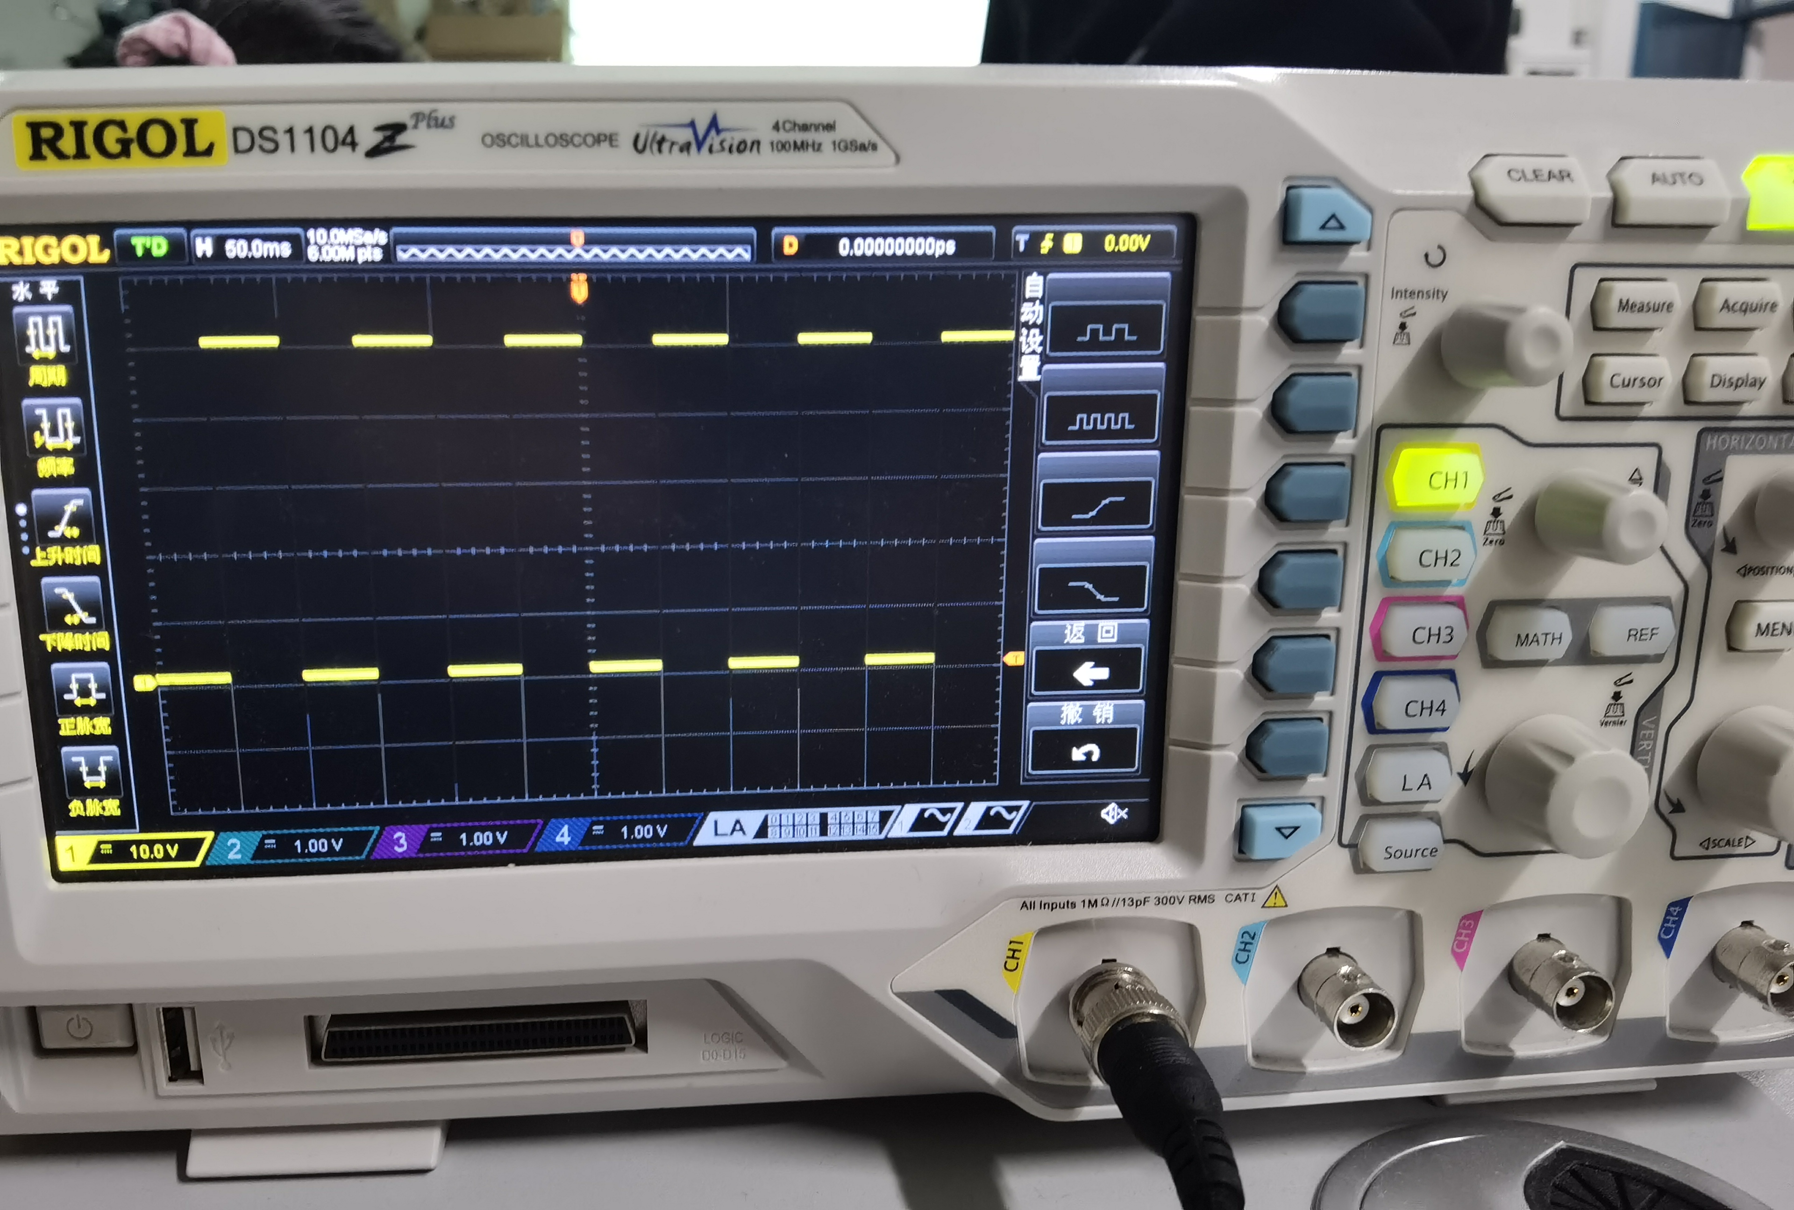

**Fig4:**

Aim at a rising edge and continuously zoom in on the abscissa, you can see a signal that is not a square wave, as shown in the following figure:

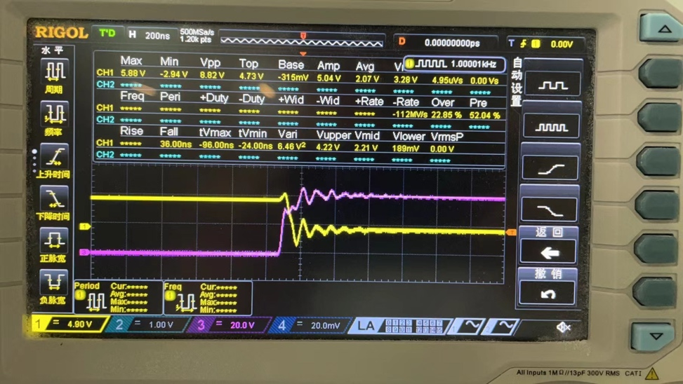

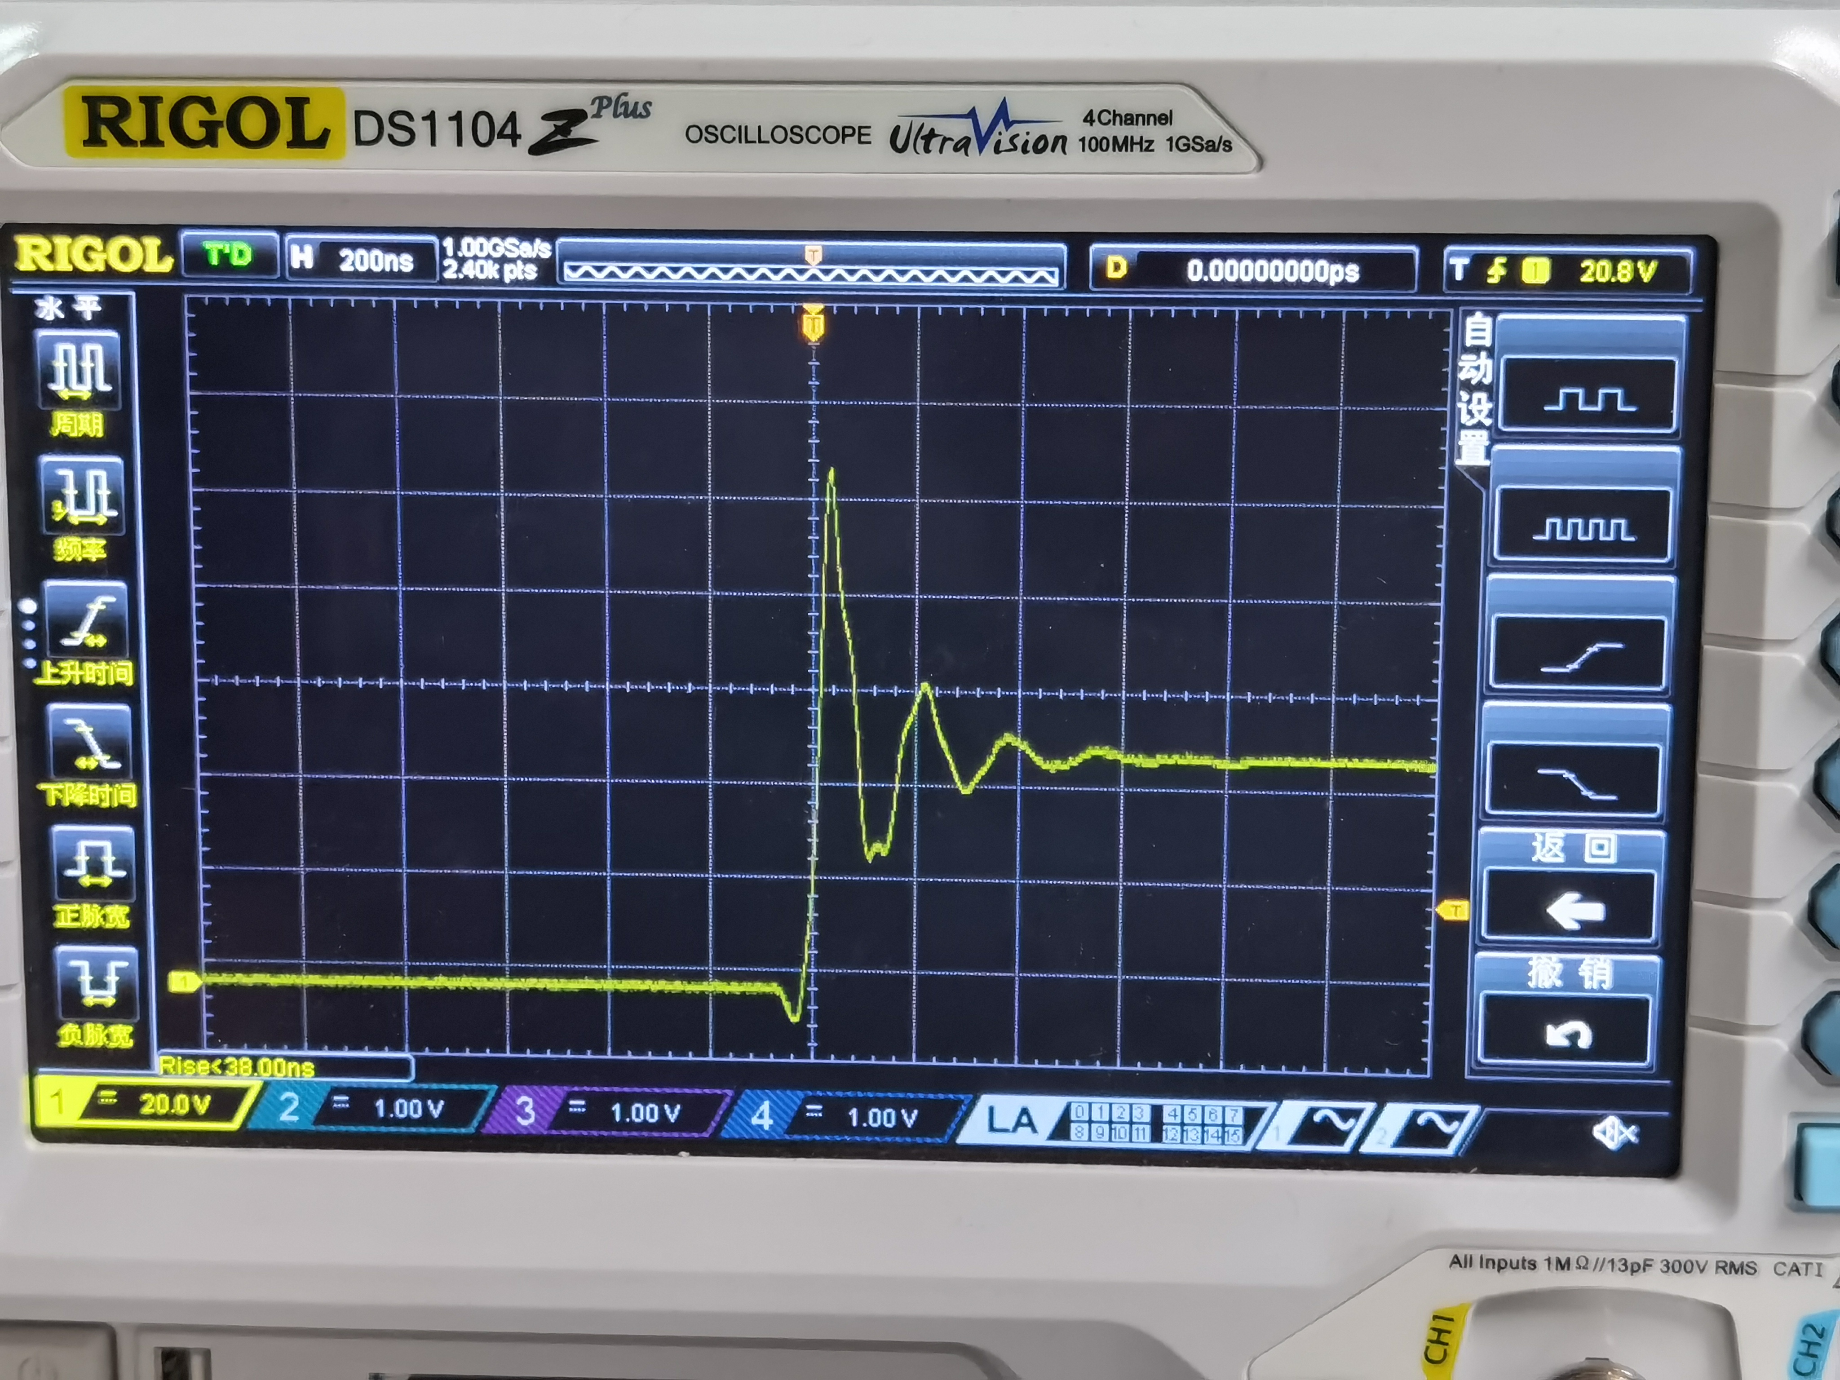

**Task.2**

**Fig5:**

When I remove 1K-resistance and LED at the output-end and connect a 1uF-capacitor, the circuit wiring diagram is shown as follows:

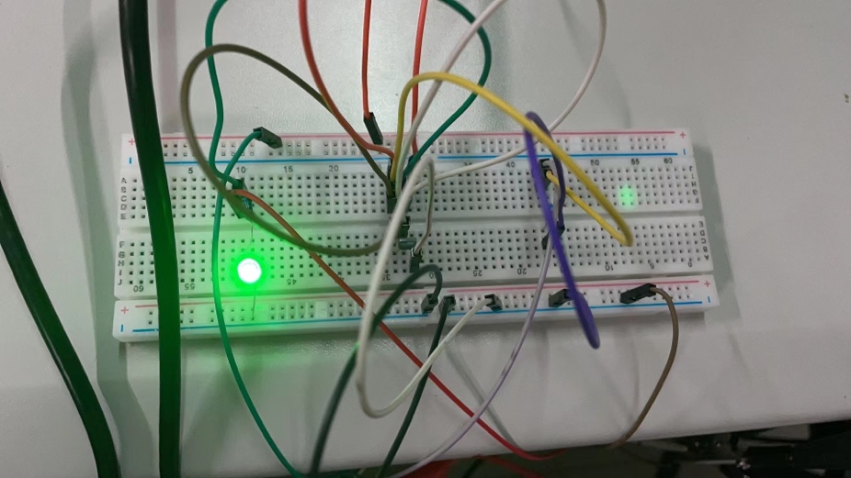

**Fig6:**

Then the input and output waveforms are as follows:

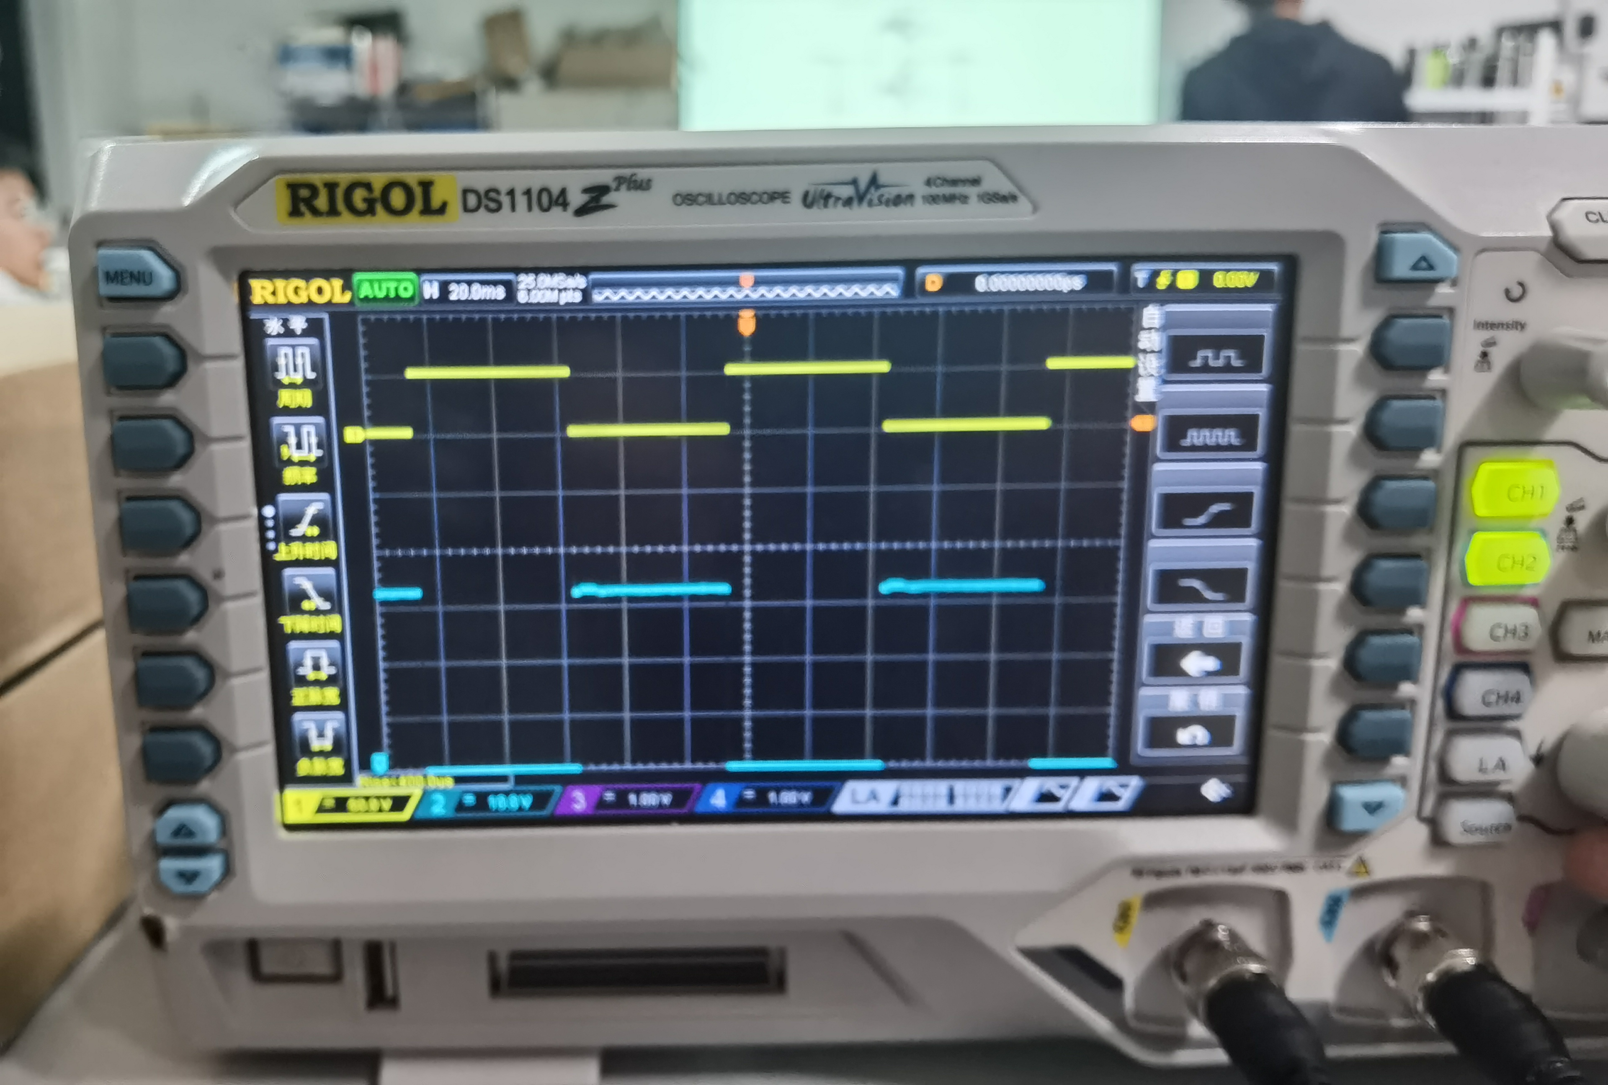

When I aim at a rising edge and continuously zoom in on the abscissa, I can see that the signal is not a square wave:

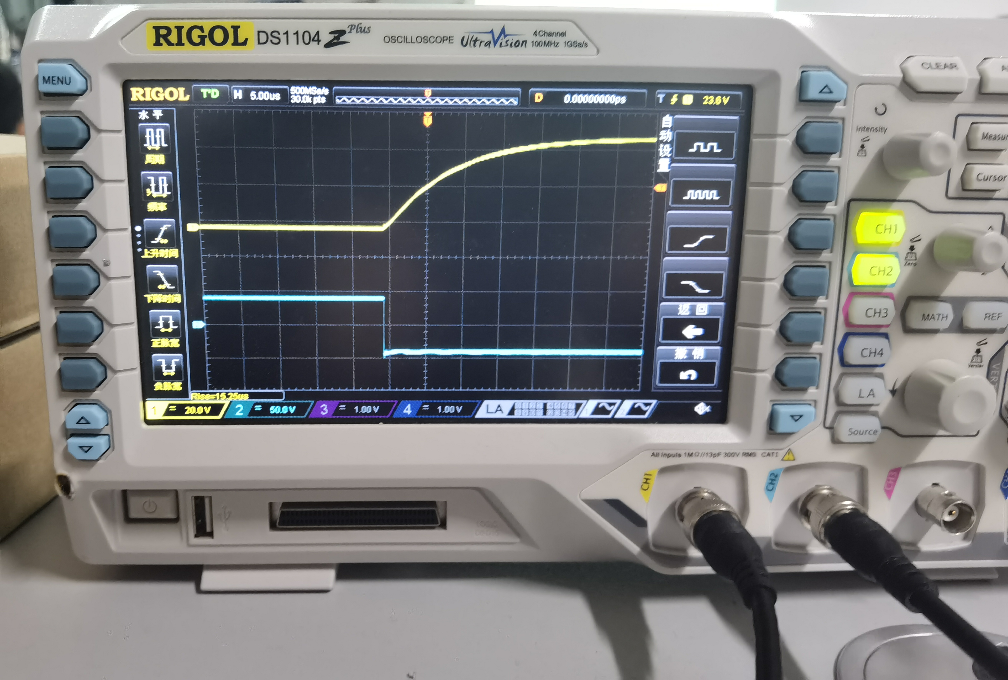

1. The amplitude to 3VPP and the signal frequency to 500HZ:

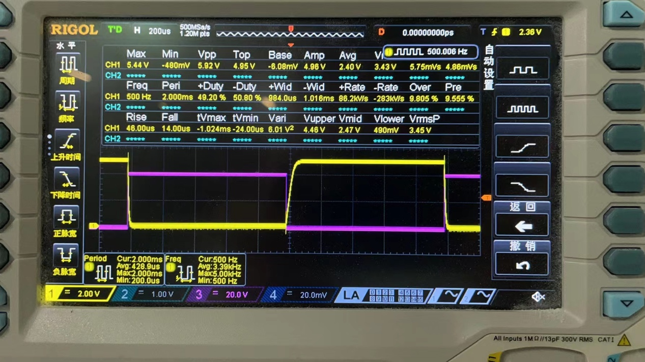

1. The amplitude to 3VPP and the signal frequency to 1000HZ:

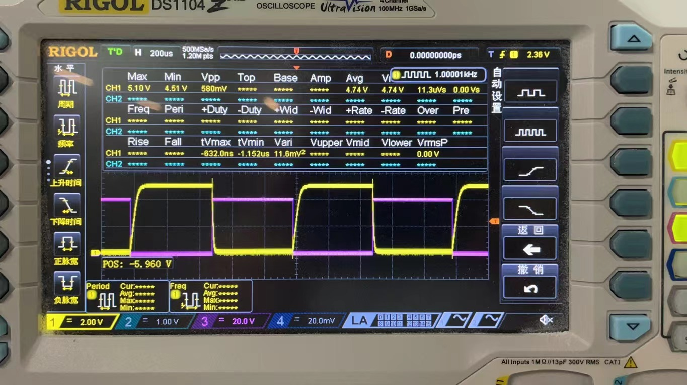

1. The amplitude to 3VPP and the signal frequency to 2000HZ:

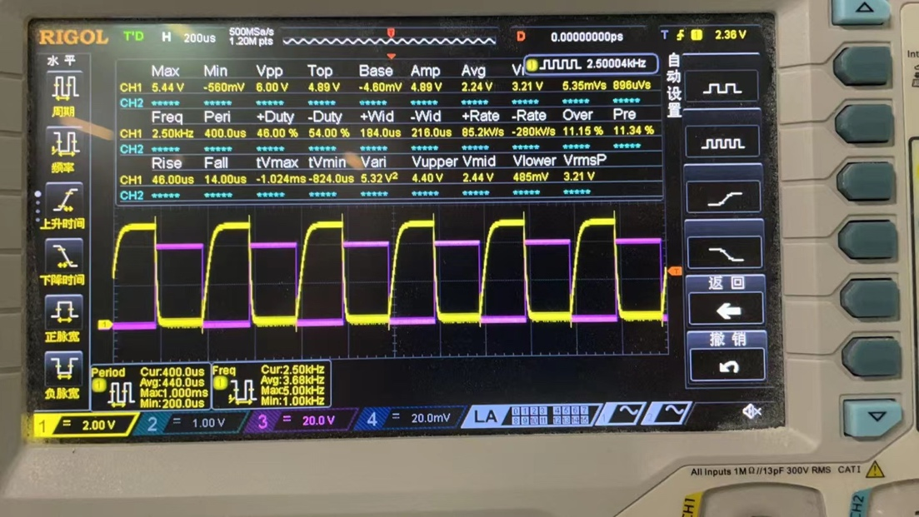

1. The amplitude to 3VPP and the signal frequency to 5000HZ:

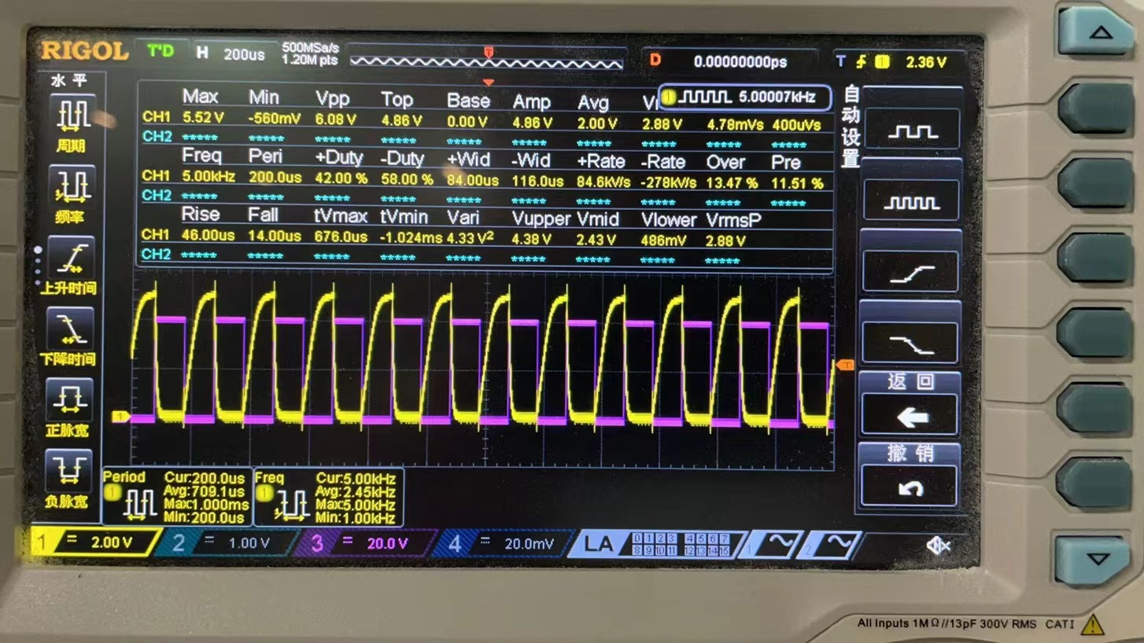

**Summary & Comments:**

Through this experiment, I learned how to use function transmitter and oscilloscope, and mastered the circuit connection more skillfully. Not only that, I also recognize some factors that affect the performance of digital circuits. By changing the circuit structure and using capacitance, I know the impact of adding capacitance at a node of the circuit on the circuit performance. By changing different frequencies, I can get the impact of different frequencies on the inverter.

That’s all, thank you so much!

//832002117. 20122161. Hanlin Cai